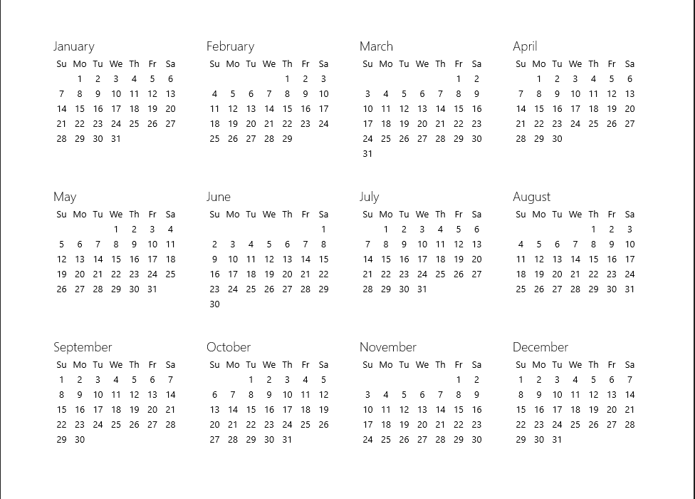

2024 REGULAR COUNCIL MEETING SCHEDULE